**ASSIGNMENT 3**

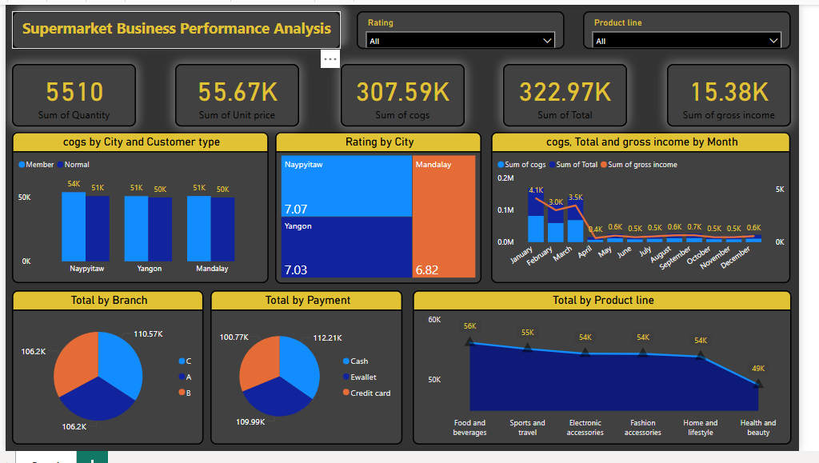

* **Insights from the Supermarket Business Performance Analysis Dashboard**

1. **Cost & Sales Trends by Month:**
2. **More sales and high costs in January to April.**
3. Gross Income also follows the same pattern.
4. **Performance by City & Customer Type:**
5. Best customer ratings in Naypyitaw (7.07), lowest in Mandalay (6.82).
6. Similar sales in all cities (~₹50K-₹54K each).
7. Members and Normal customers spend nearly the same.
8. **Payment Methods & Branches:**
9. **Credit Card is the most preferred payment method (₹112.21K),** followed by **E-wallet (₹109.99K) and Cash (₹100.77K).**
10. Branch C earns the most (₹110.57K), while A & B earn slightly less.
11. **Best & Worst Selling Products:**
12. **Best-Selling: Food & Beverages (₹56K), Sports & Travel (₹55K).**
13. **Lowest-Selling: Health & Beauty (₹49K).**
14. **Sales & Profit Overview:**
15. **Total Items Sold: 5,510**
16. **Total Sales: ₹322.97K**
17. **Total Cost (COGS): ₹307.59K** (Money spent to buy products)
18. **Profit (Gross Income): ₹15.38K**